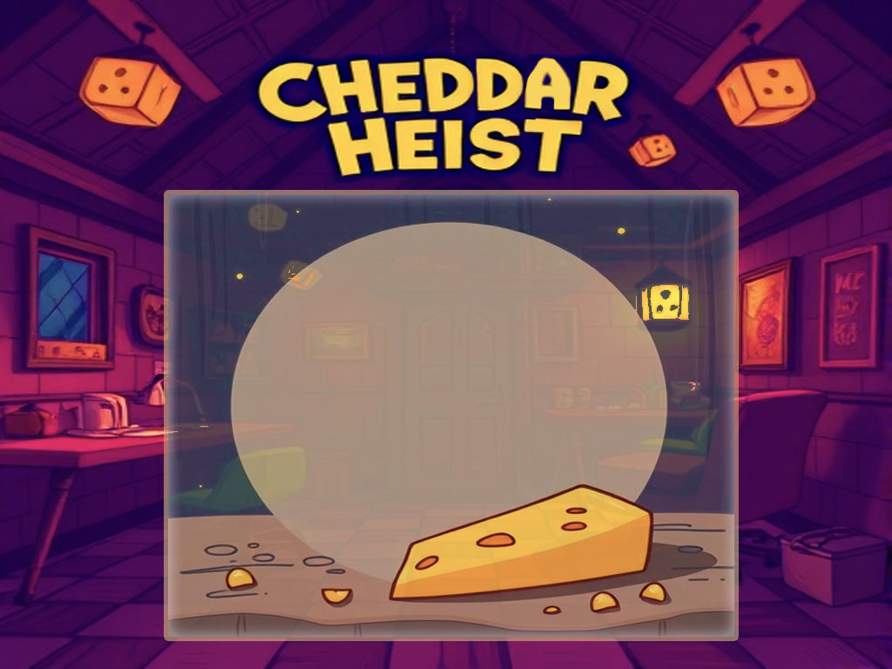

***AI PROJECT CI5525***

***Kingston University London***

***LEONIDS GUROCKINS  
K1908148***

***Teacher: Dr Jarek Francik***

Pages:

CHEDDAR HEIST 3

SELF ASSESSMENT 3

Game Plot: 3

GAME CONCEPT & INSTRUCTIONS 3

MOVEMENT & SKILLS 3

AI TECHNIQUES AND ALGORITHMS 4

Enemies: 4

DISCUSSION 4

Game Screenshots 5

-YouTube URL here – 5

-GitHub REPO here – 5

Credits and References 5

# CHEDDAR HEIST

|  |  |
| --- | --- |
| SELF ASSESSMENT | |
| My project is: | nearly finished |
| My scene is: | meeting all the coursework requirements |
| My effort was: | I worked hard and I am proud of my results |

# GAME PLOT:

You play as a mouse whose main goal in life is to stay well-fed, and a big piece of cheddar lying in the kitchen is supposed to help you achieve this desired dream.

The main game aspects are stealth, strategy, and various types of combats or avoiding them while you are navigating through the house.

Hide, fight the enemies use all the game potential and take that cheese back to the mouse hole without getting killed.

# GAME CONCEPT & INSTRUCTIONS:

* The main goal is to take a block of cheese from the kitchen and get back to starting pos (mouse hole) and not get killed.
* You can kill or avoid regular enemies like a cat. Low-health cats will call for help from a dog - AI NPC, but you can’t kill it, as it has extremely high health and damage.
* Apart from that the dog has a static role to guard an entrance to the kitchen, and it’s extremely hard to avoid. However, if you succeed in that matter, the other AI a house owner will wait for you, and you probably will be as good as dead.
* The aim is to show the player that there are other ways to get to the goal and avoid all these troubles. You can use cats to get the dog out of the way and hide from human AI.
* You can cut the house’s electricity, which will make you invisible to everyone on the map and call the house owner to come and fix it, when the light is fixed, the house owner returns to a static position in the kitchen, and everyone can see you again.
* For report
* (turn on obstacles visual – variable on top of Map.cpp file, turn on visual for node and path assist – pathfinder.cpp on top

# MOVEMENT & SKILLS:

***Player and abilities***

* Attack – primitive bite attack. (Q button)
* Hide in a shadow – making the player invisible for several seconds (W button)
* Life saver - a speed ability to run away. (E button)
* Movement – move to a position. (Right mouse and click)

# AI TECHNIQUES AND ALGORITHMS:

* Path Finder – using nodes to find a path to the destination, saves all nodes to a vector.
* Path-Smoothing – if the second node is the sight of view, it deletes the first node, as it's the better way to get to the goal.
* Patrolling – cats patrol the nearest position to them. The algorithm first finds the closest node and adds the next node connected to it and so on (depends on depth, 3 by default), then goes back to the first node, making a circle patrolling, if cats chase the player they return to the closest NEW patrolling position.
* Player detection – cats see the player if there is no obstacle and the distance is not too far away, and based on rotation, cats see the player only by 180 degrees when the homeowner and dog can smell the player and see him on a 360-degree radius.
* Following player using Pathfinder – if enemies detect the player, they follow him while he is in sight, if the player hides behind an obstacle or uses hiding skill, cats follow to the place where they saw the mouse last time and return for patrolling later. Dog and house owner will go back to static positions at once.
* Call For help – if cats have low health, they will run to a dog static position and if the dog is there, they both will return to the place where the player was seen last time. If no player is seen, the dog says, “Stupid cat” and returns to a static position, and the cat goes back to patrol.
* Light off - AI players are responding to a change of environment, if the player attacks the electricity panel, the light goes off and the house owner will go to switch it back on and return to a static position afterwards. While the light is off – the player is invisible.

# ENEMIES:

* Dogs - patrolling areas attack or bark to alert the others if they find you. Have great hearing and smell. So, they will attack you at 360 degrees.
* Cats - see player only in 180-degree range and try to attack. Call for a dog if low HP.
* Human - House owners act like a dog - a static guard, the only difference is if the light on the map is off it goes to switch it back on.

# DISCUSSION:

* Code clearness and DRY approach – now it’s not done, will try to do my best, but unfortunately can’t sacrifice other modules for this, sorry. (Enemy class has an extreme amount of repetitive code.
* Baffs and throwing objects are not done, as described in the proposal.
* Other bugs appear from time to time with pathfinding and call for a dog.
* Mixing 2.5d assets and a top-down view of the character is probably not the best idea.
* Probably I should have focused more on AI implementation than the game aspect.

# -YouTube URL here –

# -GitHub REPO here –

# Credits and References

Apart from Sprites references below, all the rest are purely AI generated or are bought under license which do not require any references to it.

* RPG - Interior, (2018) Available at: <https://img.itch.zone/aW1hZ2UvMjkzNjg5LzEyMjEyMTUzLnBuZw==/original/m01ztu.png> (Accessed: 4 November 2024).
* House interiors, (2023) Available at: [https://penzilla.itch.io/top-down-retro-interior](https://penzilla.itch.io/top-down-retro-interior%20) (Accessed: 4 November 2024).

# Game Screenshots

